

SCHOOL OF PSYCHOLOGY

118 College Drive #5025 | Hattiesburg, MS 39406-0001

Phone: 601.266.5411 | Fax: 601.266.5580 | mark.huff@usm.edu | www.usm.edu

April 14, 2019

Psychonomic Society

2424 American Lane

Madison, WI 53704-3102

Dear Graduate Travel Award Section Committee:

With great pleasure I am writing this letter on behalf of Nicholas Maxwell to support his travel to the 2019 Psychonomic Society meeting in Montreal, QC, Canada. Nick is currently pursuing a PhD in Cognitive Psychology in my lab at The University of Southern Mississippi and this award will greatly assist Nick in attending this year’s conference. In addition to providing Nick with the opportunity to present his research, this award will greatly help with his educational development and afford him critical networking opportunities as he seeks a career as an academic in the Cognitive Sciences.

Nick is fully eligible for this award: He is currently a graduate student who is enrolled in our PhD program and will be the first author presenter on his submitted poster. Additionally, I am a Fellow of the society and will be sponsoring his submission to the conference. As you will see from Nick’s submission, he did a fine job in preparing a brief research summary for the project and preparing an abstract for the conference. I can verify that Nick’s submission is entirely his own. I am very proud of Nick’s efforts on this project and I hope that you find his application suitable for funding for this year’s conference.

If you have any questions about Nick’s conference submission or his application, please do not hesitate to contact me following my contact information below.

Sincerely,

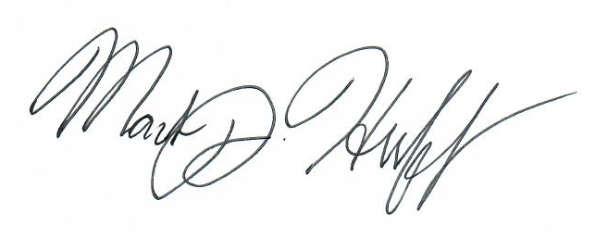

Mark J. Huff, PhD

Assistant Professor, Psychology

The University of Southern Mississippi

601.266.5411

mark.huff@usm.edu